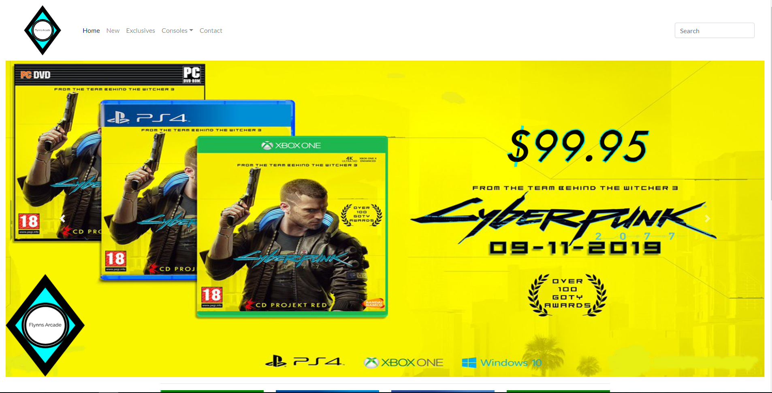

Flynn’s Portfolio

Shawn Reynolds | IST | 30/08/19

Contents

**Design Brief** 2

**Research** 3

**Design sketches** 4

**Final Concept design** 5

**Design changes** 6

**Evaluation** 7

**Bibliography** 8

# **Design Brief**

Flynn’s Arcade has been slowly losing money as the trend for accessing video games has moved away from social ‘video game arcades’ to at home ‘video game consoles such as the Atari and Commadore 64. Flynn wants to reposition his business as a venue for selling new games and trading used games. Flynn wants you to design and create ‘alpha phase’ website that communicates his new business model (More information on Flynn’s Arcade: <http://tron.wikia.com/wiki/Flynn’s_arcade>)

# **Research**

A

# **Design sketches**

# **Final Concept design**

# **Design changes**

# **Evaluation**

# **Bibliography**